HAJEE MOHAMMAD DANESH SCIENCE AND TECHNOLOGY UNIVERSITY, DINAJPUR- 5200



Department of Civil Engineering
Course Code: CIE 412
Course Title: Structural Analysis & Design Sessional-III

Submitted To:
Md. Shahriar Reza
Lecturer,
Dept. of Civil Engineering, HSTU

Submitted By:
Md. Amir Hamza
Dept. of Civil Engineering
Level: 4 Semester: I
Student ID: 2007313

……………………………………
Signature of the Course Teacher

INDEX

SL No. | Name of The Chapter | Page No.
01 | Introduction | 3 - 5
02 | Overview of ETABS | 6 - 7
03 | Analysis of a 5-Storied Building | 8 - 35

Chapter 1
INTRODUCTION
  - General:
Analysis and design of structure is very important for structural safety. Structural design software in civil engineering is used for designing, analyzing and optimizing buildings, bridges and other structures, ensuring they are safe, efficient and compliant with regulation. The use of software is very time saving in designing and it works much accurately. This chapter describes preliminary discussion about analysis and design.
1.2 Structural Analysis and Design
1.2.1 Analysis:
Structural analysis is a branch of civil engineering and mechanical engineering that focuses on understanding how structures such as buildings, bridges and machines respond to various loads and forces. Its primary purpose is to ensure the safety, stability and performance of these structures.
1.2.2 Design:
Structural design is the process of creating a detailed plan and framework for a building, bridge or other structure to ensure that it can safely and effectively support the intended loads and fulfills its functional requirements. This involves determining the layout of structural elements, selecting appropriate materials and specifying the dimensions and connections of the components, all while adhering to relevant building codes and safety standards.
1.3 Analysis Methods:
1.3.1 Manual analysis:
Manual analysis can be grouped as-
- Determinate Structural Analysis: Determinate structure is the structure which can be
solved by using equilibrium equation. These types of structures can be solved by the
following methods-
➢ Conjugate Beam Method.
➢ Double Integration Method.
➢ Moment Area Method.
➢ Basic Equilibrium Equation etc.
- Indeterminate Structural Analysis: Indeterminate structure is the structure which can’t
be solved by using equilibrium equation. These types of structures can be solved by the
following methods-
➢ Slope Deflection Method.
➢ Moment Distribution Method.
➢ Stiffness Matrix Method.
➢ Flexibility Matrix Method.
➢ Influence Line Diagram.
➢ Relative Stiffness etc.
1.3.2 Software analysis:
Following softwares are widely used for Structural analysis and design-
➢ ETABS
➢ STAAD Pro
➢ Tekla Structures
➢ Autodesk Revit
➢ SketchUp
➢ SAP2000
1.4 ETABS for structural analysis:
ETABS allows the user to model with a friendly graphical
mode. In ETABS, models are created, and results are reported at the object level. It enables the
designer to focus on macro-economic performance objectives. The editor mode provides
sufficient options to model complicated structural models with ease. Its powerful features and
easy to use interface make it an essential tool for any engineers working on concrete or steel
structures.
ETABS is preferred over other structural analysis software due to the following advantages:
User-Friendly Interface:
Offers one of the most intuitive and easy-to-use interfaces for structural modeling.
- Advanced Load Modeling:
Provides enhanced load modeling capabilities for accurate analysis of complex loading conditions.
- Improved Material Simulation:
Allows better simulation of different construction materials through advanced material modeling features.
- Energy Efficiency Tools:
Includes tools for analyzing energy efficiency, aiding in the design of more sustainable buildings.
- Seismic Analysis Features:
Equipped with modern seismic analysis tools that provide deeper insights into structural performance during earthquakes.
- Continuous Updates and Development:
Actively maintained and updated by developers to incorporate the latest methods and technologies in structural engineering.

Chapter 2
Overview of ETABS
2.1 General
ETABS stands for Extended Three-Dimensional Analysis of Building Systems. It is a powerful software widely used by structural engineers, architects, and construction professionals around the world for the design and analysis of high-rise buildings, stadiums, bridges, industrial structures, and more.
This chapter provides a step-by-step overview of how ETABS functions, including structural modeling, load application, and analysis procedures.
2.2 Installation
To install ETABS, follow these steps:
Download the installation file from the official ETABS website.
Run the installer and choose to activate the software either with a trial version or by purchasing and entering a product key.
Minimum System Requirements for ETABS 18:
- Operating System: Windows 10 or 11 (64-bit)
- Processor: Intel Core i5 / i7 / i9
- RAM: Minimum 8 GB
- Disk Space: Minimum 6 GB free
2.3 User Interface
ETABS 18 offers an intuitive and interactive user interface designed for ease of use and efficient modeling. The interface includes several essential components:
- Menu Bar
- Tool Bar
- Display Windows
- Status Bar

2.3.1 Menu Bar
The menu bar provides access to a wide range of functions, including:
- File – for opening, saving, and printing projects
- Edit, View, Define, Draw, and other commands that help navigate and configure the model setup
2.3.2 Tool Bar
The toolbar includes graphical shortcuts for frequently used functions such as:
- Edit, View, Define, Assign, and more
- These tools allow quick access to key operations like assigning loads, defining materials, and modifying elements.

2.3.3 Display Windows
ETABS includes multiple display windows that offer various perspectives of the model. The three main views are:
- Model Explorer – for navigating through the model's components
- Plan View – for working on horizontal levels of the structure
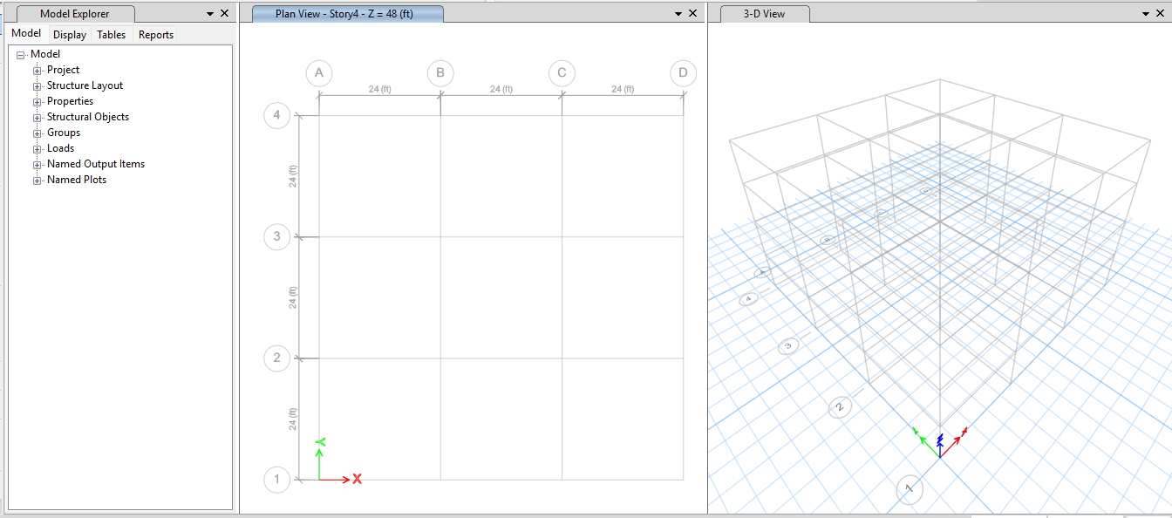
- 3D View – for visualizing the entire structure in three dimensions

2.3.4 Status Bar
Located at the bottom of the interface, the status bar provides useful information such as:
- Cursor coordinates
- Current storey and axis indicators
- Unit selection and changes

Chapter 3
Analysis of a 5-Storied Building
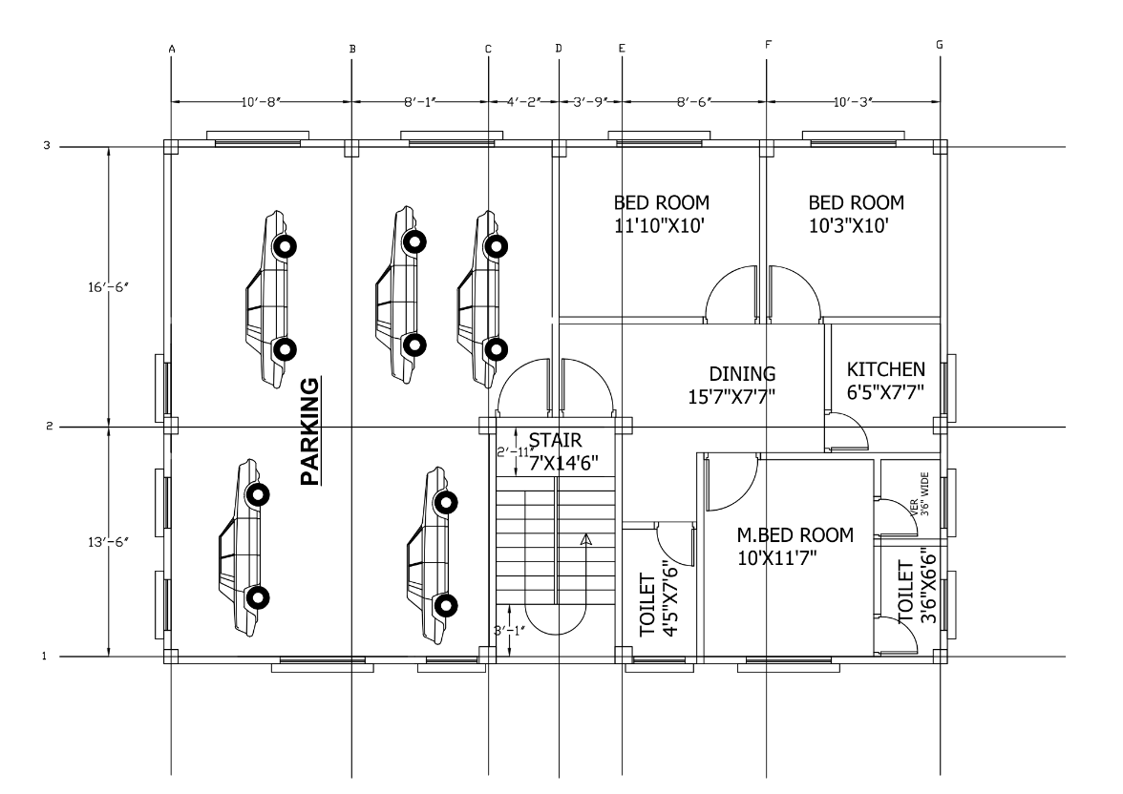
3.1 Building Plan: a 5-Storied building plan with grid lines

3.2 Model Initialization:
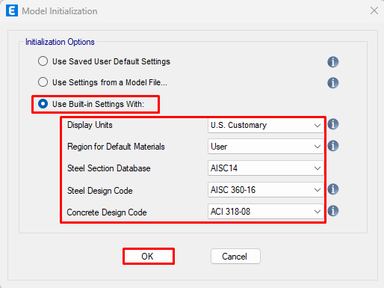
File> New model>Use Built-in settings With> Select as like the following window>OK.

3.3 Custom Grid Data:
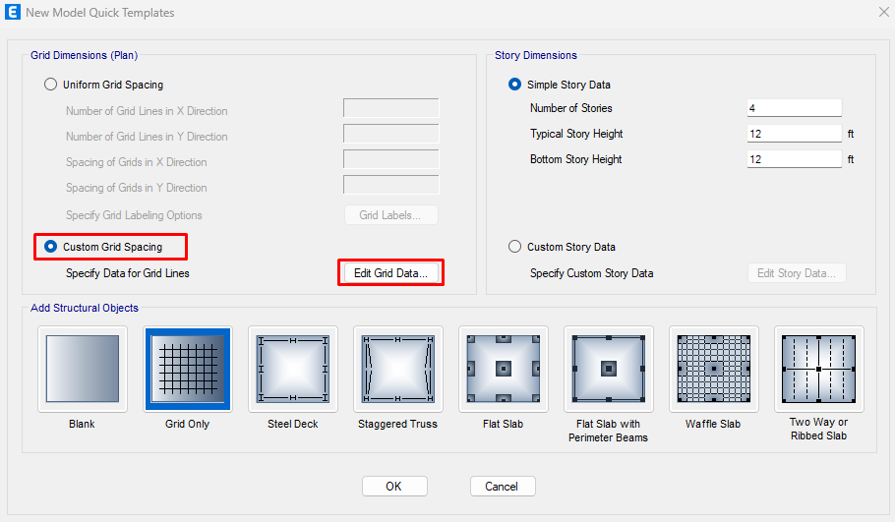
Step-1: Click on Custom Grid Spacing>Grid Only>Edit grid data

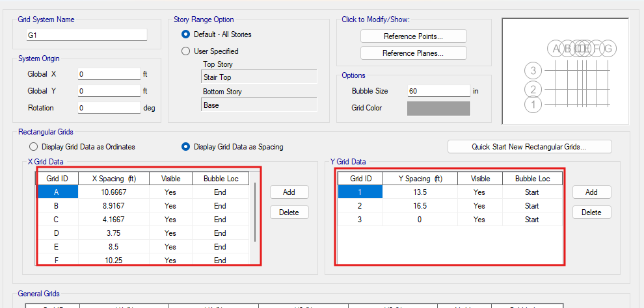
Step-2: Then click on Display Grid Data as Spacing >Insert C-C distance between 2 columns on both axes as following window>ok

3.4 Custom Story Data:
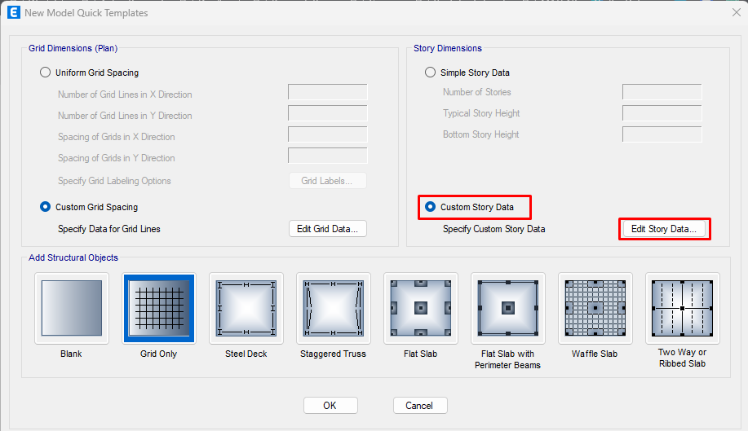
Step-1: Then click on Custom Story Data >Edit Story Data

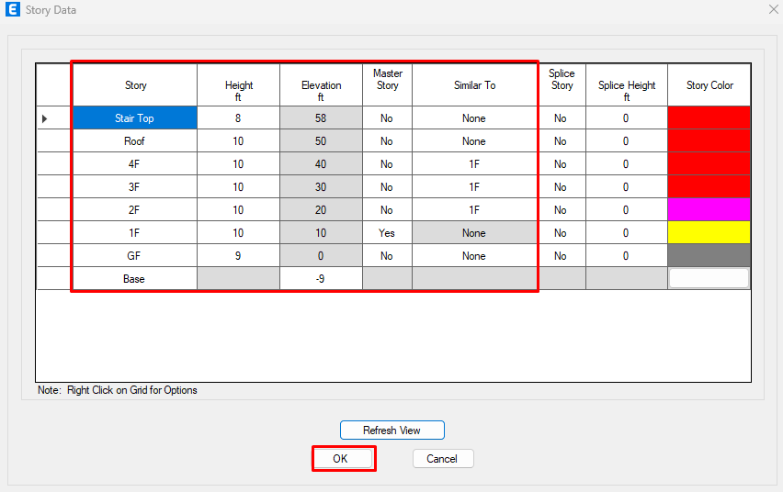
Step-2: Insert Story Name and Height as following window>ok

3.4 Define Material Properties
3.4.1 Defining Concrete:
Step-1: Define>Material Properties>Select Concrete>Add Copy of Material>Edit General Data
>Input E value>Modify/Show Material Property
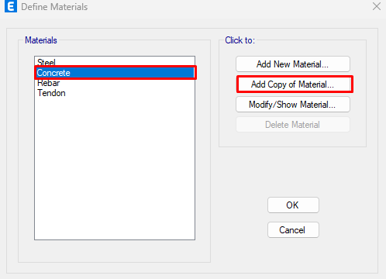
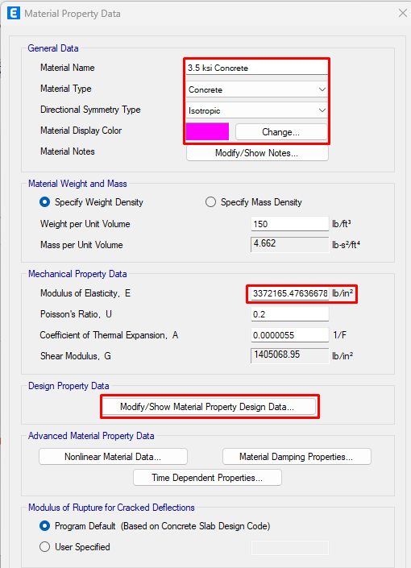

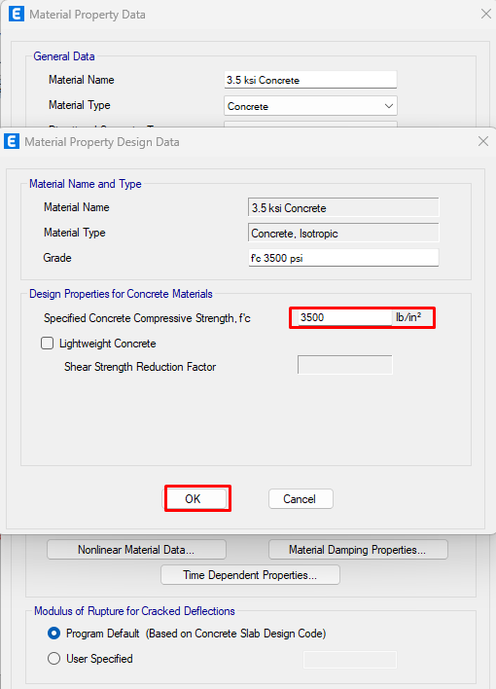
Step-2 Write the Value of Concrete Compressive Strength> OK
:

3.4.2 Defining Rebar:
Step-1: Define>Material Properties>Select Rebar>Add Copy of Material>Edit Material Name
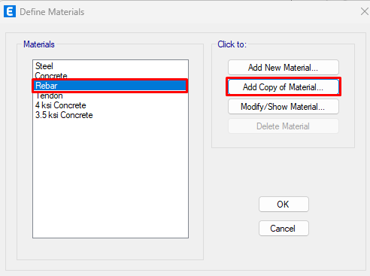
>Modify/Show Material Property
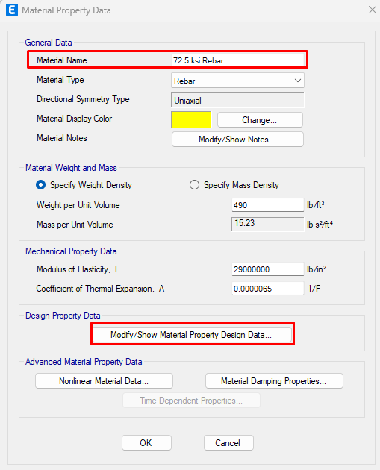

Step-2: Write the Values of Design Properties for Rebar Materials> OK

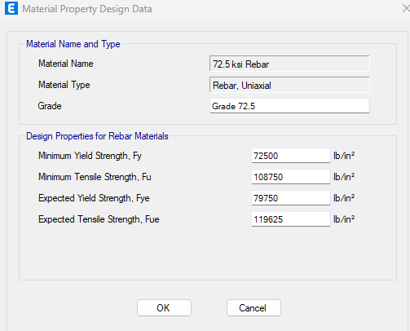
3.5 Define Frame Section
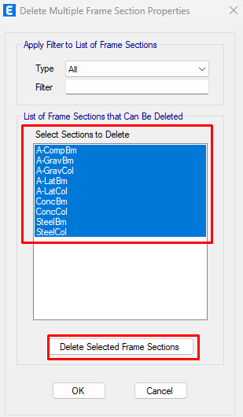
3.5.1 Defining Column:
Step-1: Define>Section Properties>Frame Section
>Delete Multiple Properties>Selecting All and delete

Step-2: Add New Property>Change Name>Write Section Dimensions>Edit Property Modifier And Reinforcement as following
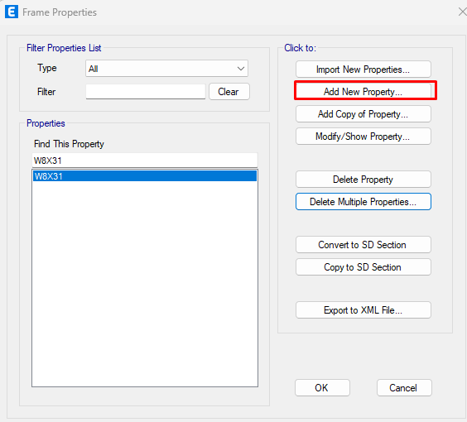

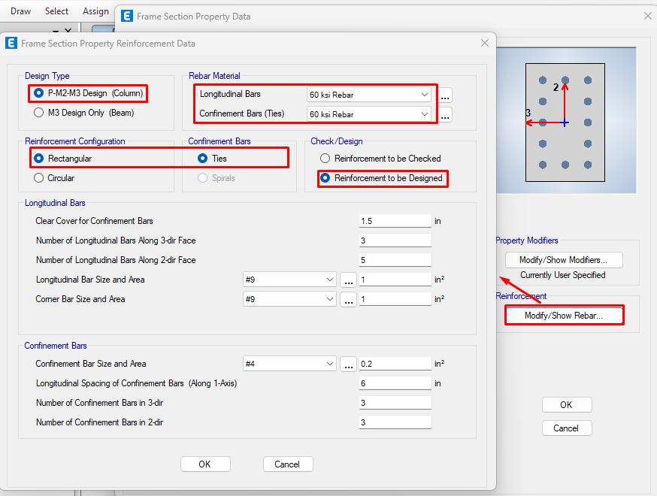
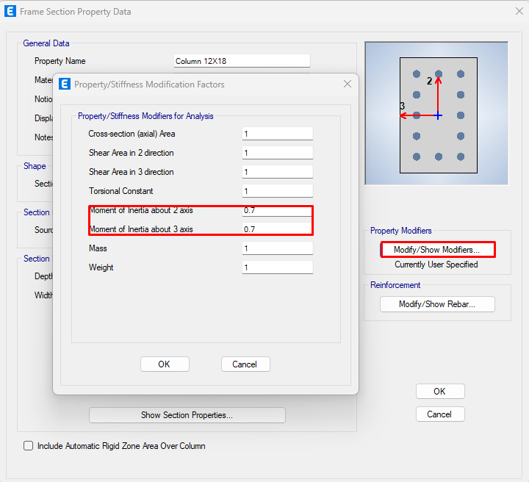

3.5.2 Defining Beam:
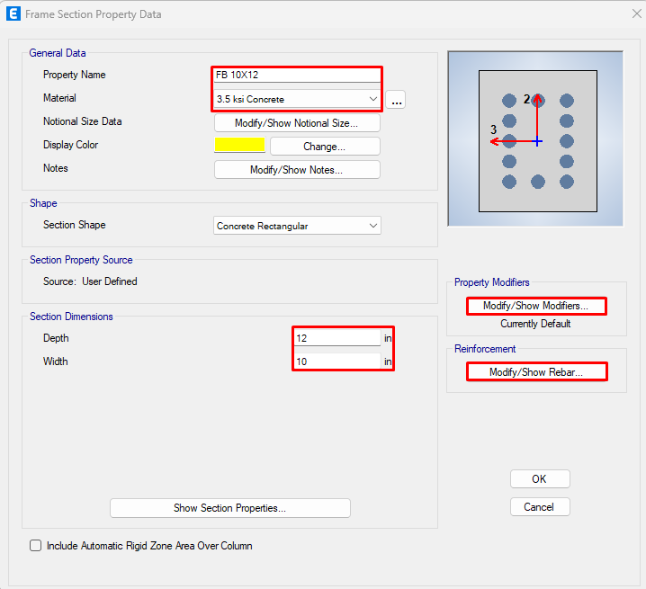
Add New Property>Edit Name>Edit Section Dimensions>Edit Property Modifier And Reinforcement as following

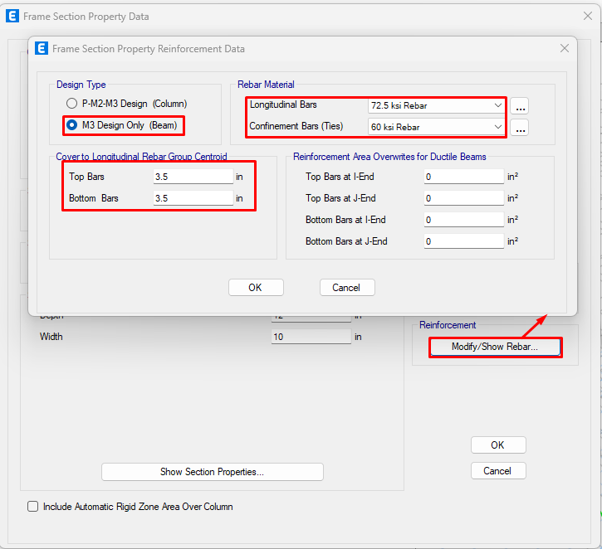
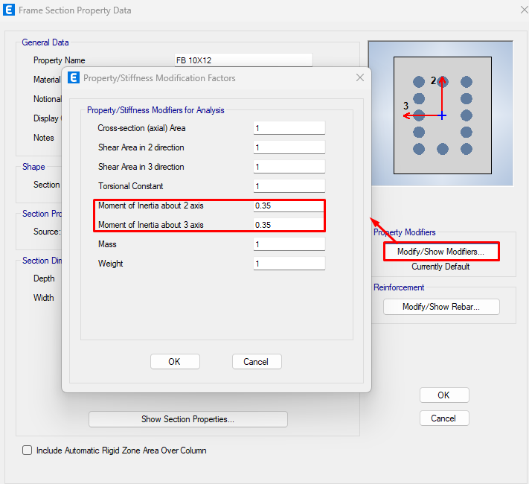

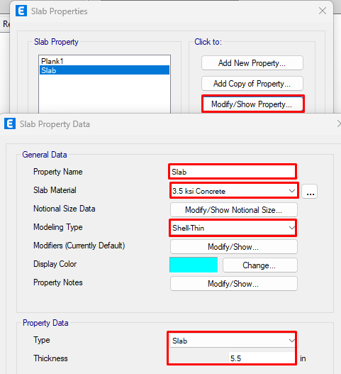
3.5.3 Defining Slab Property:
Define>>Section Properties>> Slab Section
>>Edit as following directions

3.6 Drawing Members
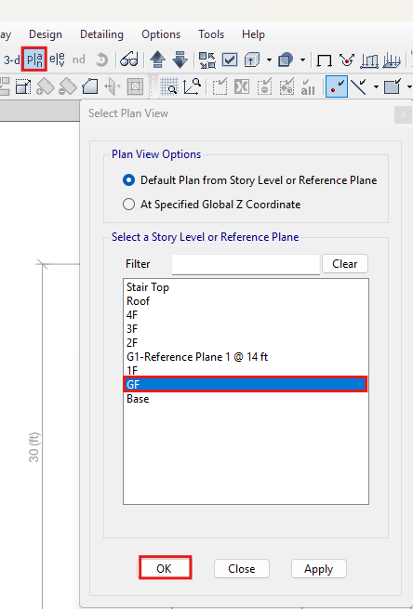
3.6.1 Drawing Column:
Step-1: View>Set Plan View> Click on desired level

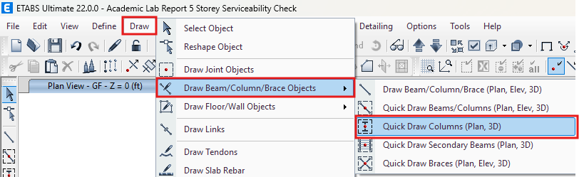
Step-2: Draw>Draw Beam/Column/Brace Objective>Click on Quick Draw Column>Draw columns

3.6.2 Drawing Beam:
Draw > Draw Beam/Column/Brace Objective > Select Draw Beam/Column/Brace
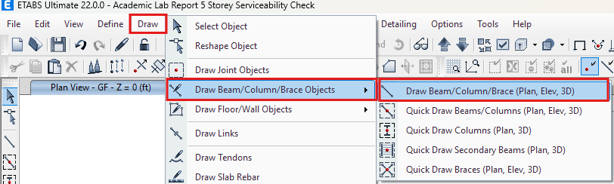

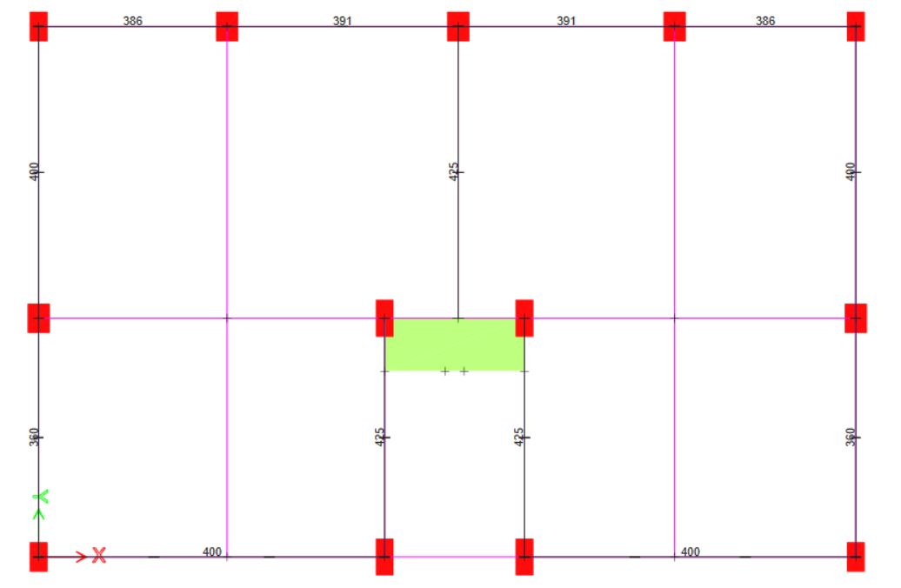
Step-2: > Connect Columns with this tool

3.6.3 Drawing Slab:
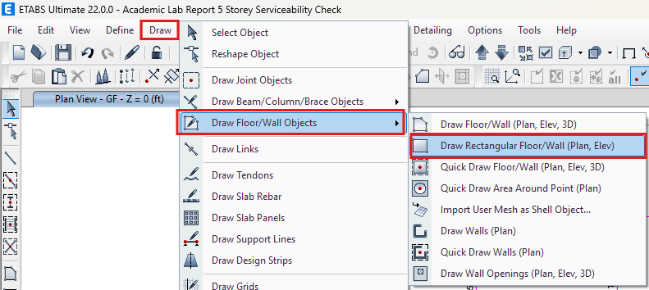
Step-1: Click on Draw Rect. Floor

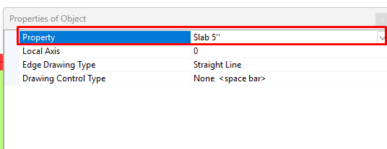
Step-2: Select slab property (Thickness)

Step-3: With the tool click on a corner of a room and drag to another corner
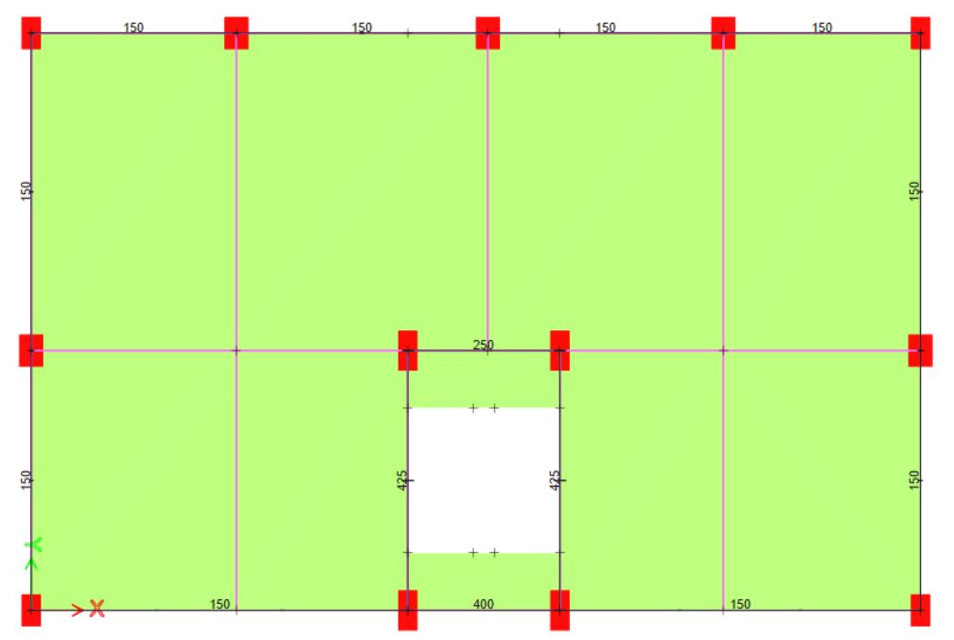
3.6.4 Drawing Stair:
Step-1: Go to 3D>Select Beams of Stair Portion>Elevation(B)>Click Draw>Draw Reference Plan
Step-2: Go to Plan View>Create Landing
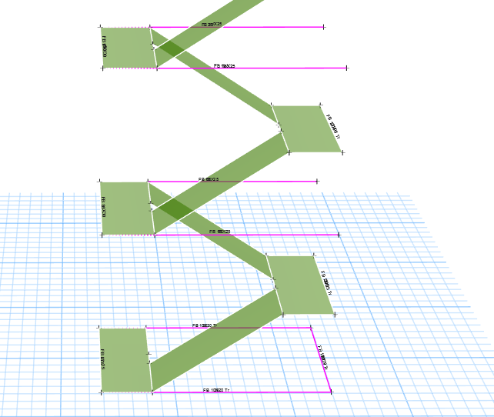
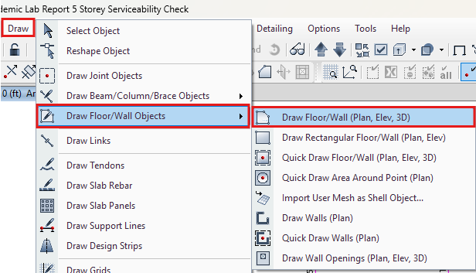
Step-3: Create Inclined Stair Slab by "Draw Floor/Wall" tool

3.7 Assign Support on Base
Step-1: Plan View>Base>Select all joints
Step-2: Assign>Joint>Retrains>Select Fixed>Apply
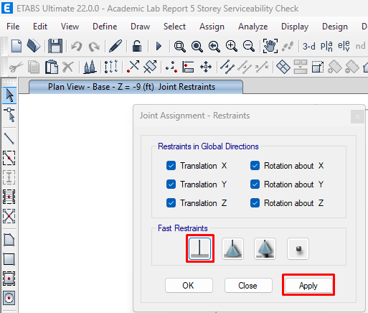
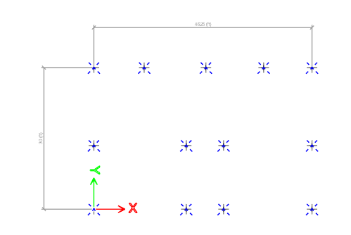

3.7 Assign Diaphram
Step-1: Go to Every Plan View Individually>Select One Story (at Right-Bottom)
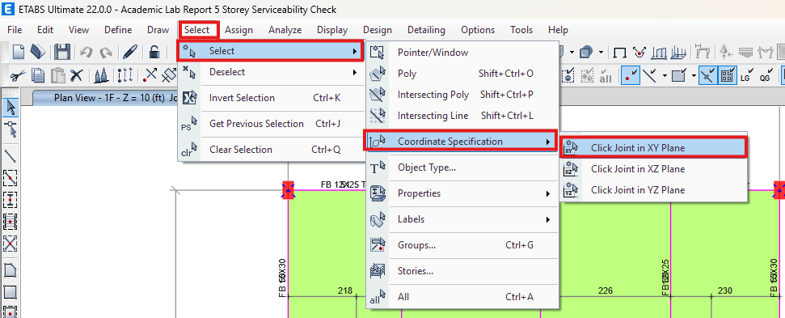
Step-2: Click on Select tab>Select>Coordinate Specification>XY Plane

Step-3: Assign>Shell>Diaphrams>D1>Rigid>Apply

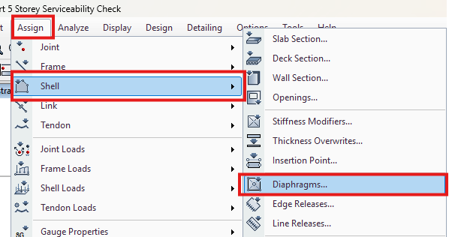

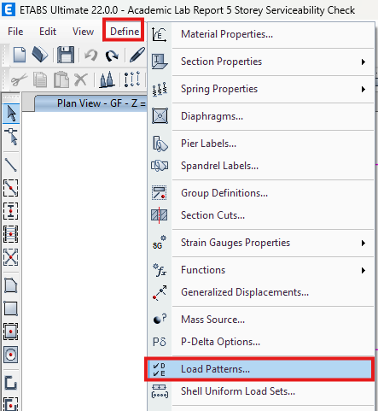
3.8 Define Load Pattern
Step-1: Define>Load Pattern

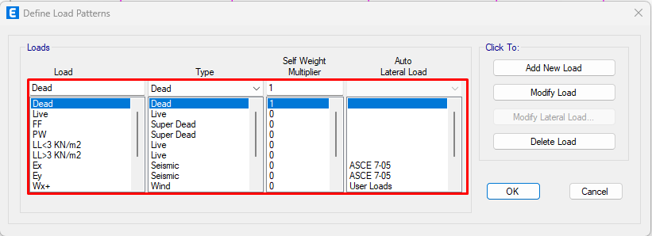
Step-2: Define various loads (Dead Load, Live Load, Wind Load, Earthquake/Seismic Load)

3.9 Load Assignment
3.9.1 Load Assignment on Floor:
Step-1: Select>Object Type>Floors >Show Selected Object
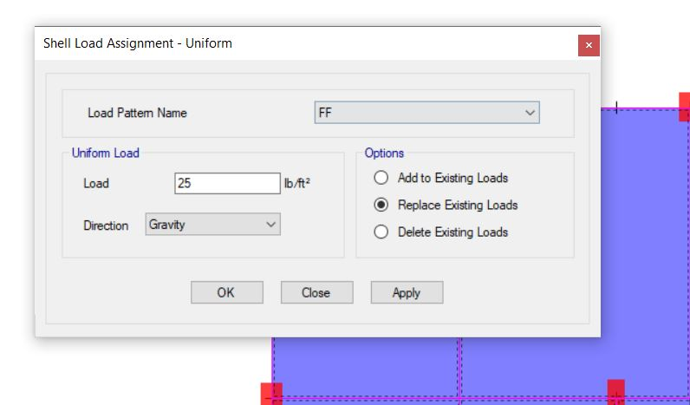
Step-2: Assign>Shell Load>Uniform

3.9.2 Live Load Assign
- LL on Stair Slab
Step-1: Select>Properties>Slab Section>Slab 7”
Step-2: Click Right Button>Show Selected Object
>Select all slab of stair
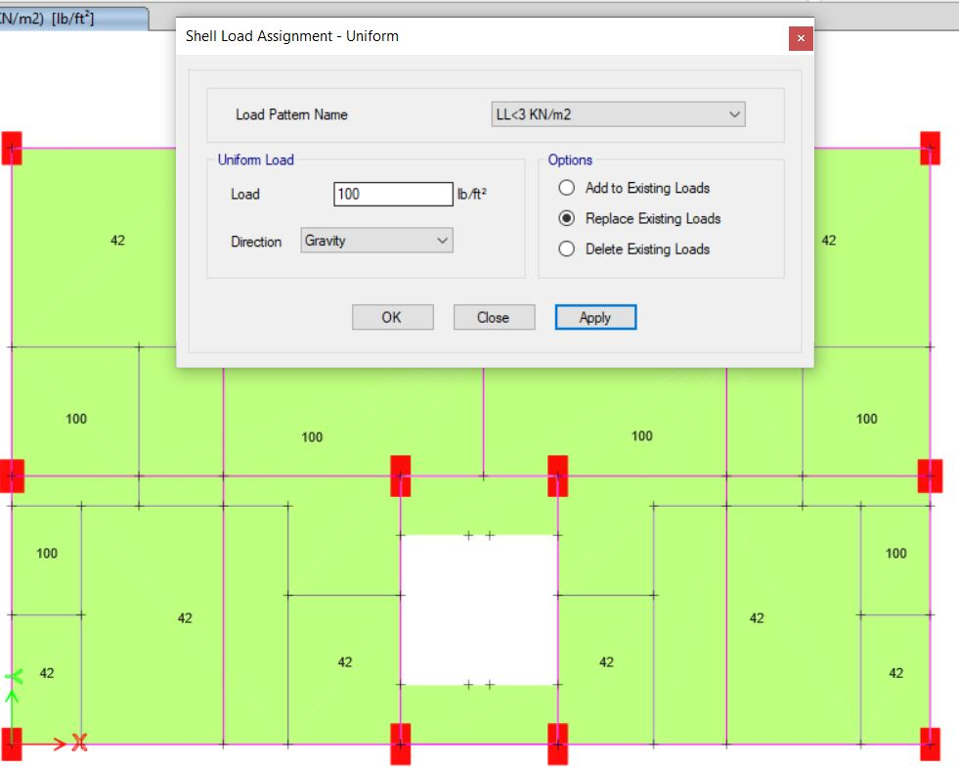
Step-3: Assign>Shell Load Assignment

- LL on Roof:
Step-1: Go to RL Plan View>Select all slab without stairs
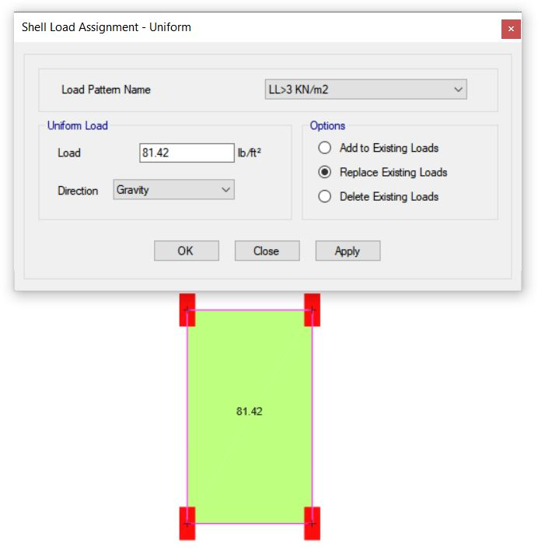
Step-3: Assign>Shell Load Assignment

    - Seismic Load Assign
- Seismic Load on X Direction:
Step-1: Define>Load Pattern>Select EX>Modify Lateral Load
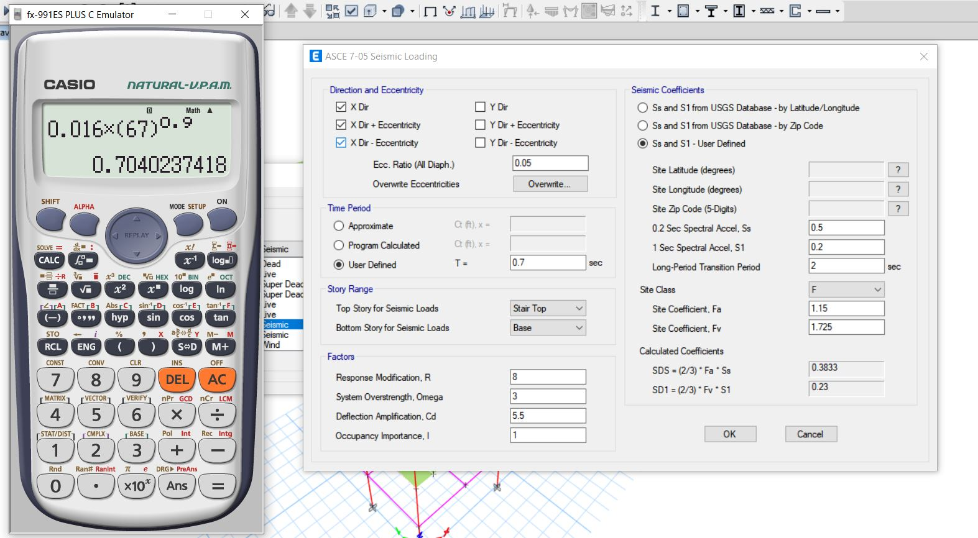
Step-2: Input Values As Following

- Seismic Load on Y Direction:
Step-1: Define>Load Pattern>Select EY>Modify Lateral Load
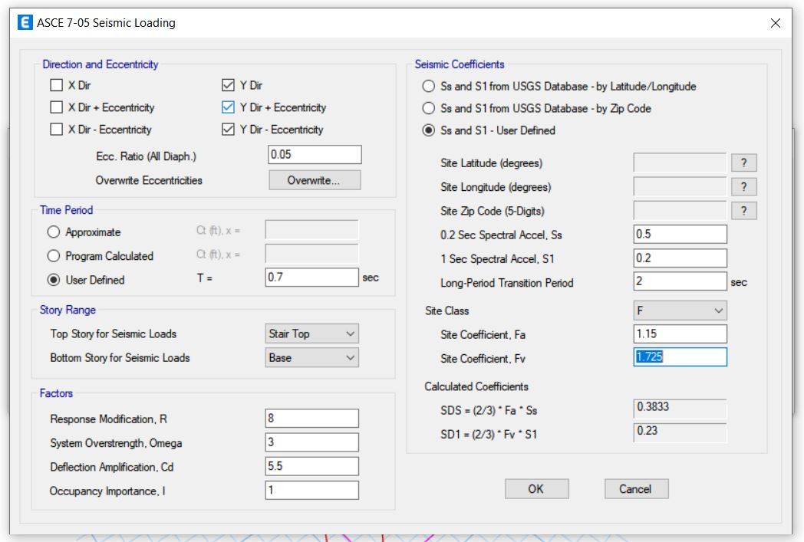
Step-2: 2: Input Values As Following

3.9.4 Wind Load Assign
- Wind Load on X Direction:
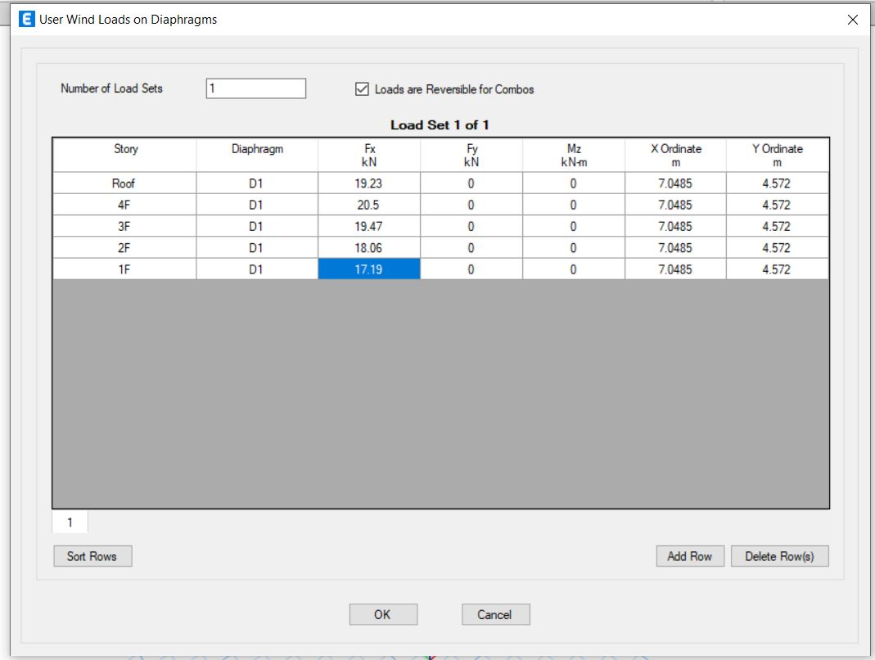
Step-1: Define>Load Pattern>Select WX>Modify Lateral Load>Input Values from 1F - Last Floor

- Wind Load on Y Direction:
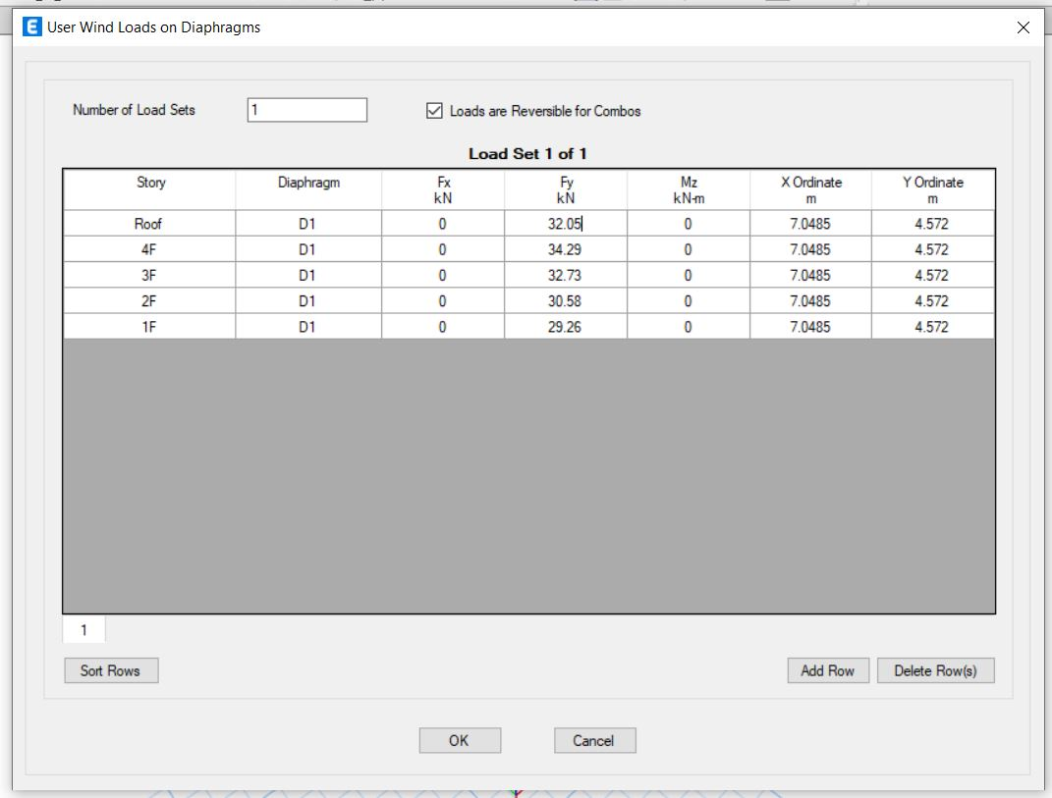
Step-1: Define>Load Pattern>Select WY>Modify Lateral Load>Input Values from 1F – Last Floor

  - Load Combination
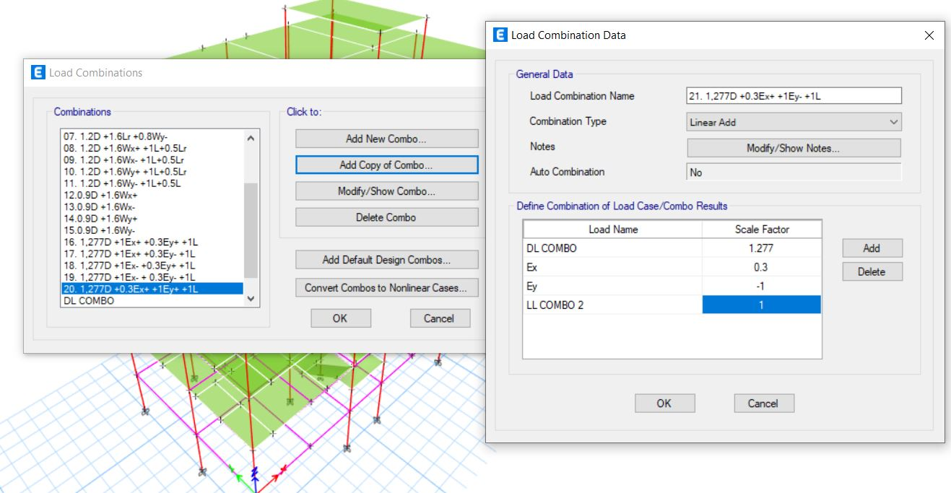
Step-1: Define>Load Combination>Add New Combo

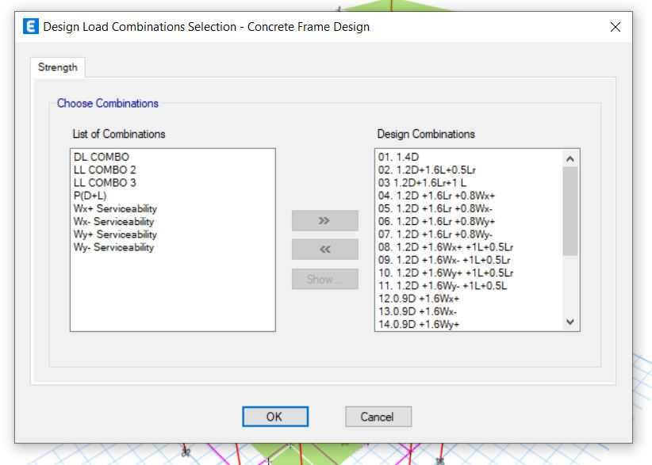

  - Apply Mesh

- Mesh on Beam/Column/Frame:
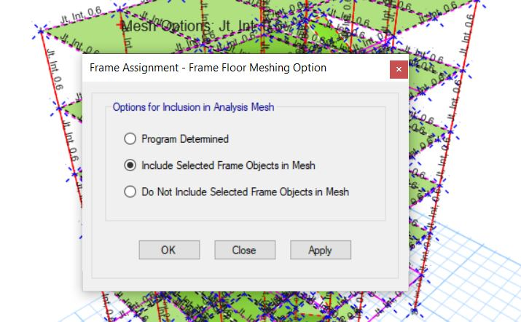
Step-1: Select full structure>Assign>Frame>Frame Floor mesh>Include Selected Frame Objects in Mesh>Apply

- Mesh on Slab:
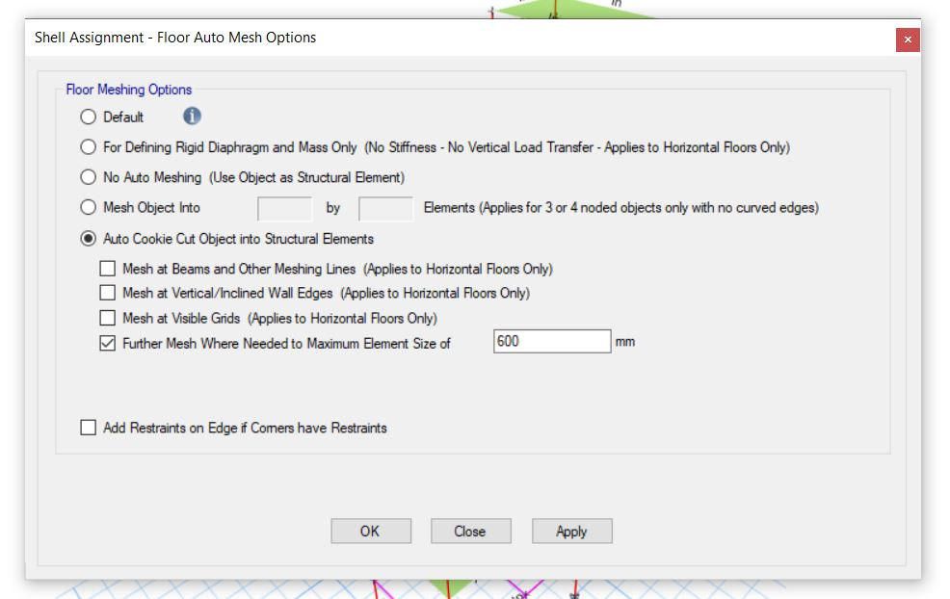
Step-1: Select total structure>Assign>Shell>Floor Auto Mesh>Auto Kookie Cut>Apply

  - Stability Analysis

    - Checking The Model: This is an analysis to find error.
Step-1: Analyze>Check model
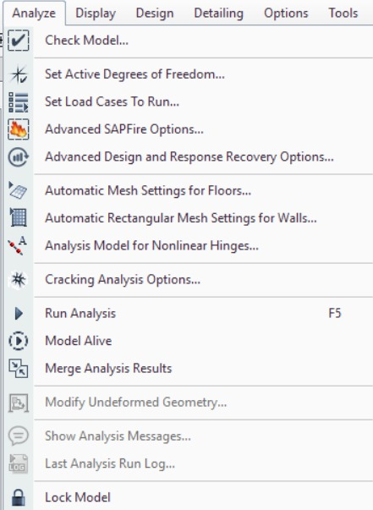

Step-2: Select/Deselect All>Ok
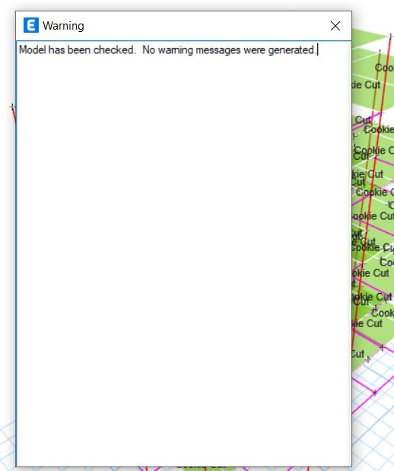
3.12.2 Linear Static Analysis:
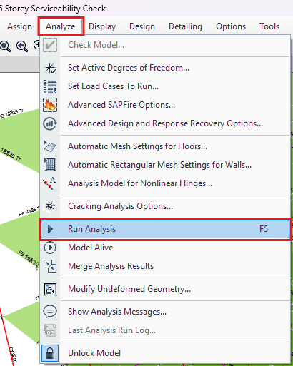
Step-1: Analyze>Run Analysis

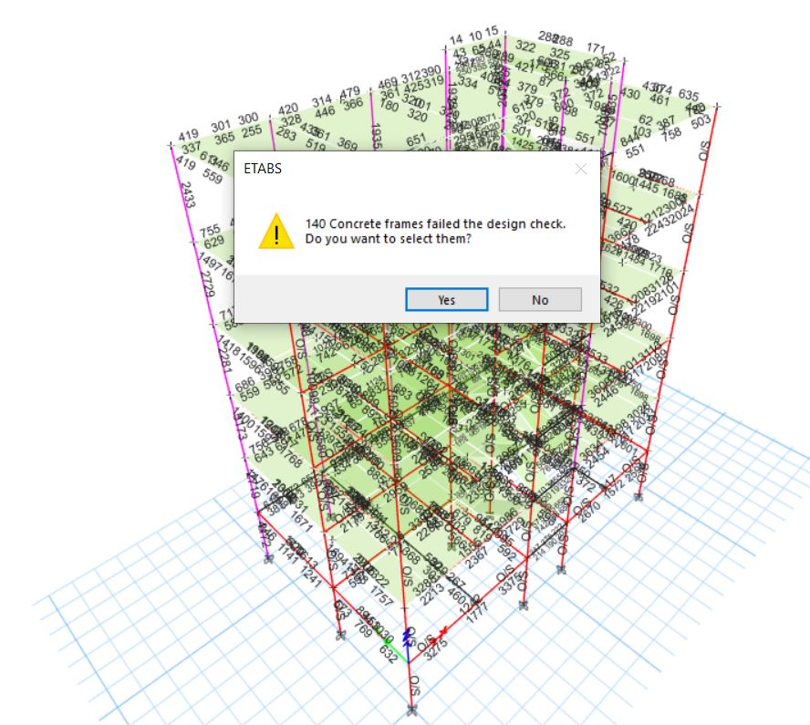
Step-2: Click on Yes
  - Checking Over Stressed Members:
After finishing analysis, we have to find out over stressed members which will be red coloured.
Step-1: Design>Concrete Frame Design>Click on “Verify all member passed”>Yes
Step-2: Go to Plan View
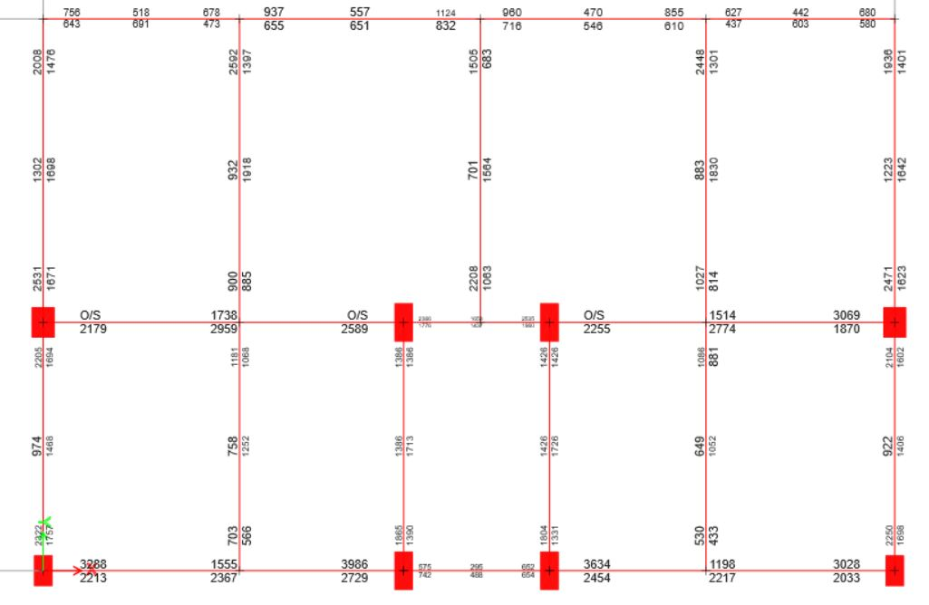

  - Solving Failed Members:

3.14.1 Ways to solve over stressed members:

- Increasing Section of Beam/Column
- Increasing Strength of Beam/Column
- Changing the orientation of Column

3.14.1.1 Changing the orientation of Column

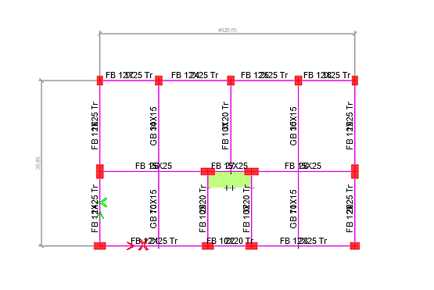

3.14.1.2 Analyzing Newly Oriented Structure:

Step-1: Analyze>Run Analysis

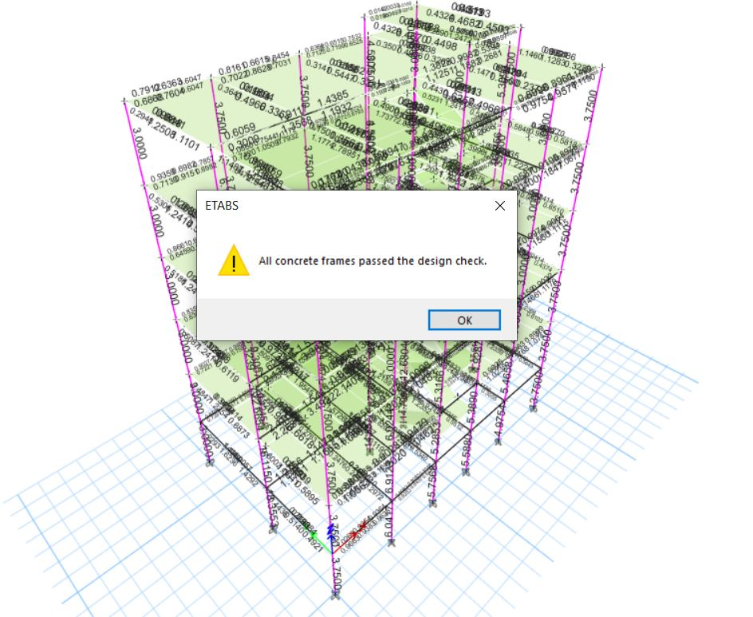
Step-2: Click on Ok

So, all members have passed the check by correcting the structure.

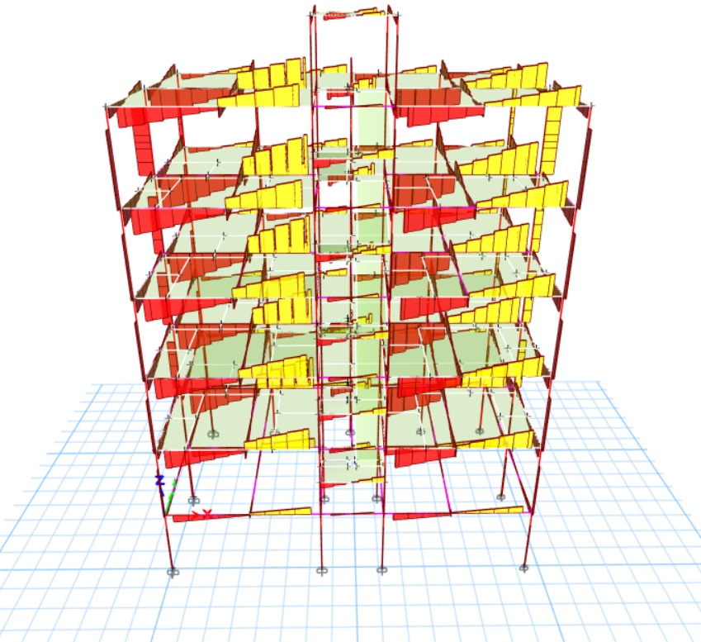

Fig: Shear Force Diagram

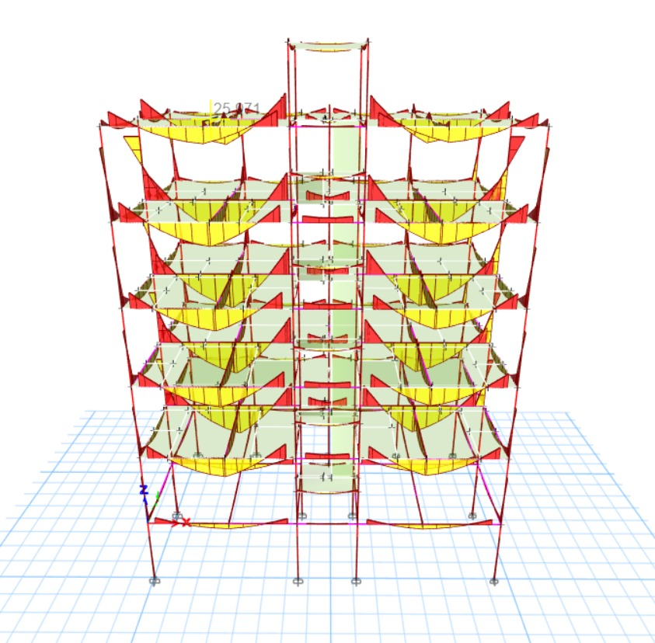

Fig: Moment Diagram

  - Serviceability Check:

3.15.1 Eccentricity check:

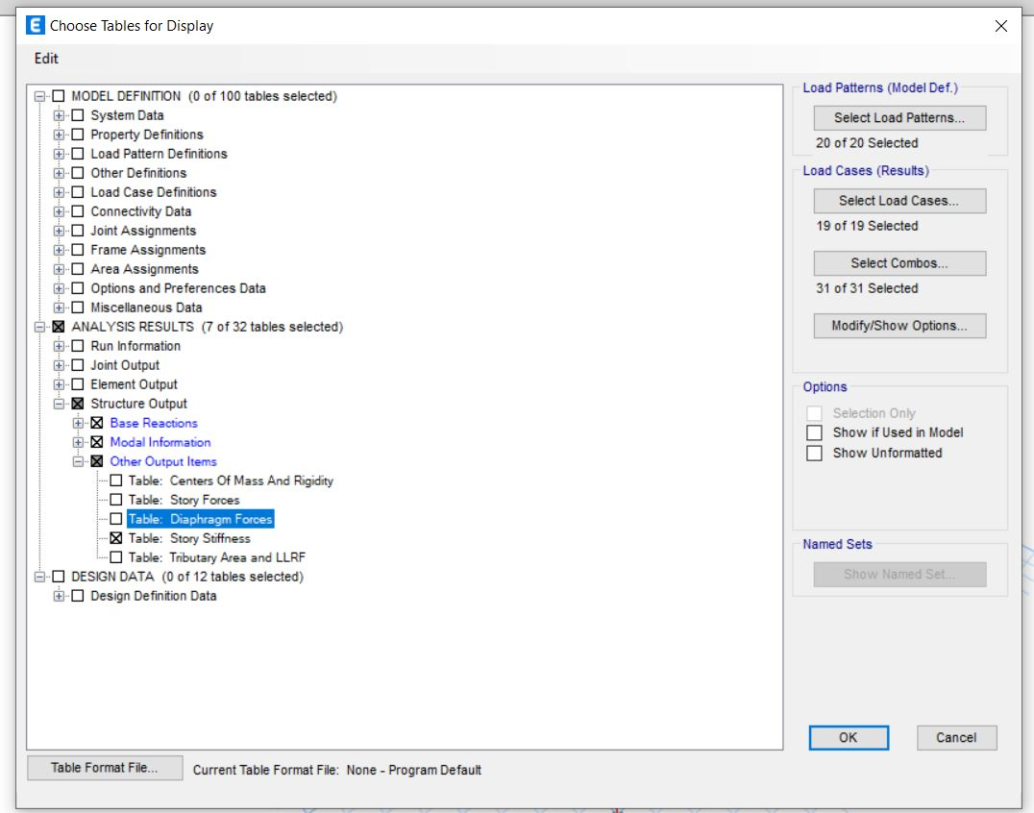

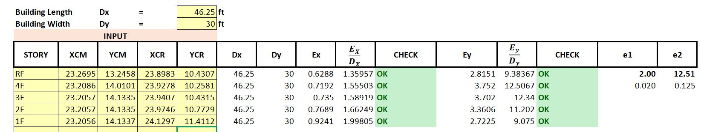
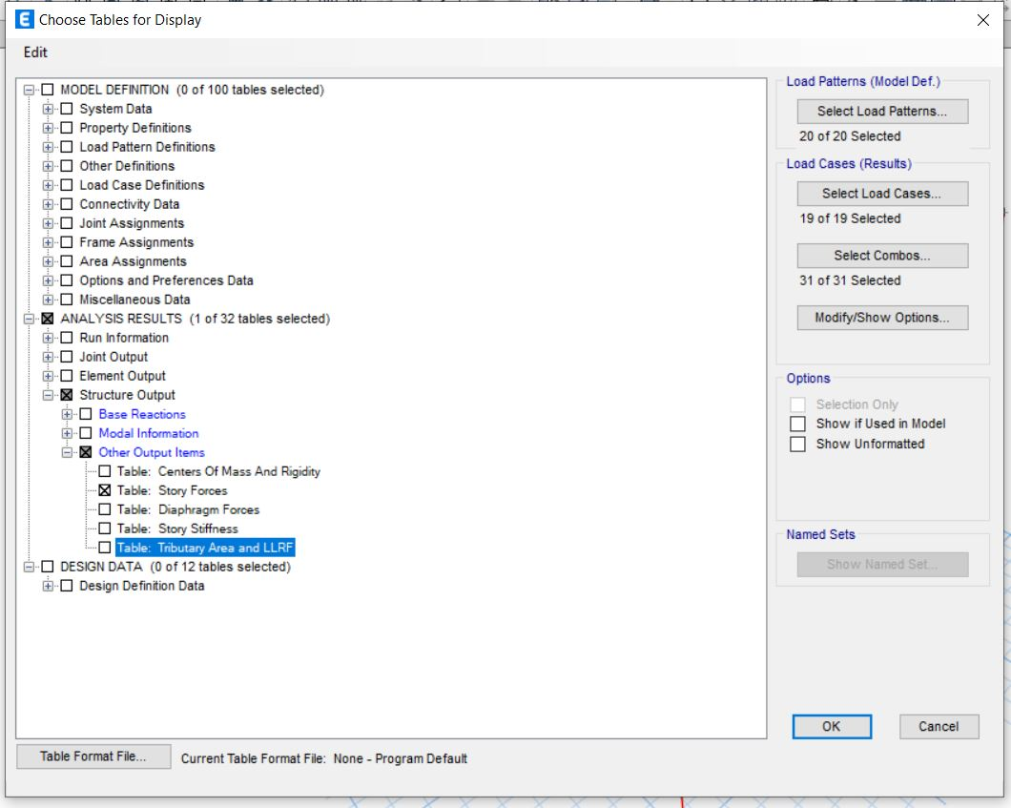

    - Torsional Irregularity Check:

